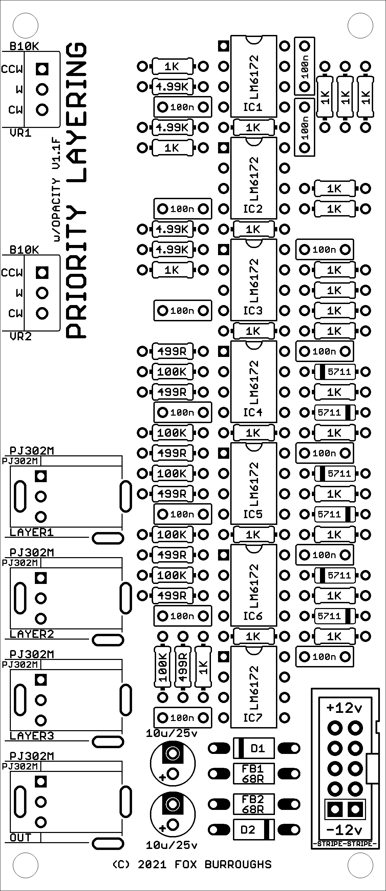
VEIL (v1.1F)
DIY BUILD GUIDE
This build guide assumes the user has basic knowledge of through hole components, soldering skills and various tools required to Do-It-Yourself.
Assemble at your own risk and have fun.

STEP BY STEP
0. Make sure you have PCB v1.1F
1. Populate all resistors and ferrite beads. Solder and clip leads.
2. Populate all diodes, taking care to align the black band on the diode with the stripe shown on the PCB. Solder and clip leads.

3. Populate all of the ceramic capacitors. Solder and clip leads.

4. Populate all of the ICs, taking care that the notch at the top of the IC lines up with the notch shown on the PCB. Solder leads.

5. Populate the IDC power connector, taking care to line up the notch on the part with the notch shown on the PCB. Hold the connector in place while soldering.

6. Populate the electrolytic capacitors, taking care to line up the black stripe on the caps with the outlined via on the PCB. Solder and clip leads.

7. Place each the of the jacks and pots into the board and install the faceplate. Finger tighten each nut in place to ensure the jacks are straight. Solder them once you are satisfied.

8. Carefully check the solder of each component for bridges and any solder joints that may have been missed. Clean excess flux with alcohol.
You may now test it your work.
BILL OF MATERIALS
Resistors
□ 6x 100K
□ 4x 4.99K
□ 7x 499R
□ 25x 1K

Ferrite Beads
□ 2x 68R

Diodes
□ 6x 1N5711
□ 2x 1N4001

Ceramic Capacitors
□ 14x 100nF (104)

Integrated Circuits
□ 7x LM6172

Electrolytic Capacitors
□ 2x 10uF/25v

Other Parts
□ 2x 10K Right angle, linear pot
□ 4x PJ302M Jacks
□ 4x 3.5mm nuts
□ 1x 2x5 Polarized IDC Power Header
□ 1x 10-16 Ribbon Cable
□ 1x VEIL v1.1F PCB
□ 1x VEIL Faceplate

